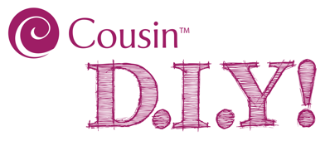
Flocked Rainbow Bead Coaster

Supplies Needed
#35021012 20pc Colors of the Rainbow Velvet Flocked 8mm Acrylic Beads (2 pk)
#22279002 E6000 Permanent Craft & Jewelry Glue, 3.7 Oz.
Cork Circle (approximately 4" in diameter)
Acrylic Paint (color of your choice)

Tools Needed
Paint Brush
Plastic Knife (for spreading glue)
Tweezers
INSTRUCTIONS:
- Paint edges of cork circle your color of choice and allow to dry.
- Use plastic knife to spread glue across the top side of the cork circle.
- Use tweezers to place flocked beads onto the glue until you have covered the entire top of the circle of cork. (Reapply glue as needed as you work along.)
- Allow coaster to dry.

Skill Level: Beginner

Approximate Crafting Time: Less than 30 Minutes (plus drying time)

