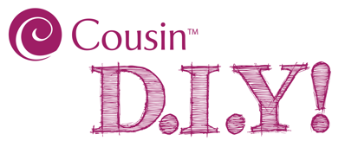
Floss Easter Eggs

Supplies Needed
#34734253 40 pc Bright Embroidery Floss (1 pk)
#34734197 18 pc Acrylic Brights Crackle Bubble Gum Beads (1 pk) *optional
Water Balloons (1 pk)
Elmer's® Washable Clear Glue (8 oz)
Water (1/4 Cup)

Tools Needed
Scissors
Plastic Fork or Spoon
Small Plastic Bowl
Tweezers
Wax Paper or Parchment Paper (to protect your work surface)
INSTRUCTIONS:
- Mix approx. 8 oz. of glue with 1/4 cup of water. Stir solution well.
- Lay parchment paper of wax paper over work surface to protect it from the glue solution.
- Stretch neck of balloon and carefully insert a crackle bead. (This step is optional.)
- Blow up balloon to desired size and tie off the neck of the balloon.
- Select color of embroidery floss and carefully unwind the skein and soak it for a minute in the glue solution. (Metallic floss not recommended for this project.)
- Starting with one end of the floss, run the floss through your thumb and forefinger to remove excess solution, and wrap it around the balloon until you come to the other end of the floss. We suggest wrapping two skeins of floss around your balloon/egg. The second skein can be the same or a different color.
- Place the wrapped balloon on a piece of parchment paper or wax paper and allow to dry thoroughly.
- Pop the balloon and use tweezers to remove the popped balloon from the middle of the floss egg.
- Repeat steps 3-7 to make several eggs.

Skill Level: Beginner

Approximate Crafting Time: Less than 30 Minutes (plus drying time)

