#
DAISY CHAIN BEADED STACKED STRETCH BRACELETS

Supplies Needed
#61215025 Glass Bronze 6/0 E-Beads, 40G (1 pk)
#69991580 Glass Matte Pink 6/0 E-Beads, 40G (1 pk)
#34733085 Glass Aqua 6/0 AB E-Beads, 40G (1 pk)
#30002029 Glass Matte Orange E-Beads, 40G (1 pk)
#61215125 Glass Blue E-Bead Mix, 40G (1 pk)
#74100006 Bead Stoppers Combo, 8 pc. (1 pk)
#JNEED2254 Big Eye 2.25”, 4 pc. Beading Needles (1 pk)
#32022 Clear Gossamer Stretch Cord, .3mm x 48’, (1 pk)

Tools Needed
Scissors
Ruler
Scotch Tape

Techniques to Know (See Illustrations)
Daisy Chain Beading
Stretch Cord Knot

MATTE PINK STACK BRACELET INSTRUCTIONS:
- Cut a 2’ length of gossamer stretch cord.
- Place a bead stopper approximately 3” from one end of the cord to hold beads onto cord. Slide the other end of the stretch cord onto a big eye needle.
- String on 3 bronze e-beads.
- String on 4 matte pink and 1 bronze e-bead. Bring the stretch cord back through the first matte pin e-bead, in the opposite direction, and pull so the beads are snug and next to the last bronze e-bead from the previous step. String on 2 more matte pink e-beads and bring the stretch cord, forward, through the fourth e-bead in this step.
- Continue repeating steps 3 & 4 until you have a total of nine repetitions of each step. (The number of daisies in your pattern can be adjusted to accommodate larger or smaller wrist sizes.)
- Make sure there are no loose or gapping areas of stretch cord and that beads are 3beaded on snug and close to one another. Use a stretch cord knot to securely tie the ends of the stretch cord together. Trim excess tails.

ADDITIONAL STACK BRACELET INSTRUCTIONS:
- Follow instructions for the Matte Pink Bracelet replacing AB blue, light blue (from blue e-bead mix), and orange e-Beads for the matte pink e-beads.

SKILL LEVEL: Beginner

APPROXIMATE TIME: Less than 1 Hr.

DAISY CHAIN BEADING

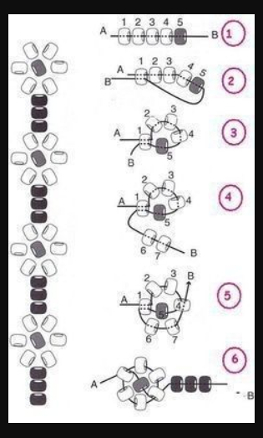

STRETCH CORD KNOT

